Data Structures and Algorithms Lab Assignment 1
Experiment 1: To Demonstrate the Use of Array, Structure, Union and Dynamic Memory Allocation
Instruction: Make a pdf file of the program code in C/C++ and its output. Name: Aryan maheshwari
SAP ID:590026023
Batch: 39
Link of your GitHub Account: https://github.com/aryanmahe2007-star/100-Days-Of-DSA
Course: B.Tech. CSE (Sem II) Subject: DSA Lab
Date: 04 February 2026
Note: Do all the implementations in C programming.
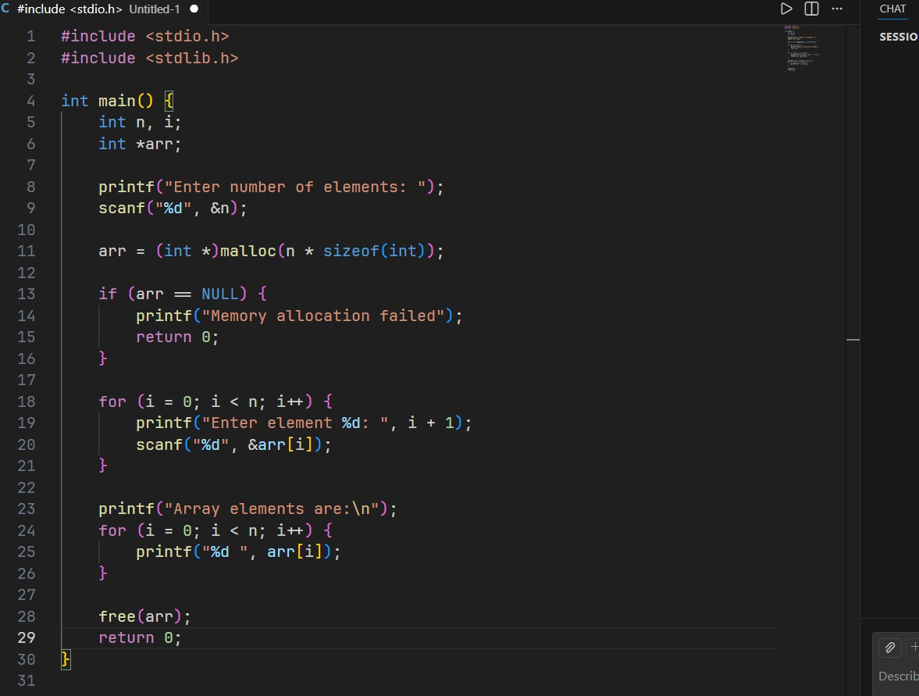
- Write a C program to dynamically allocate memory for an array, display elements, and properly free allocated memory before program termination

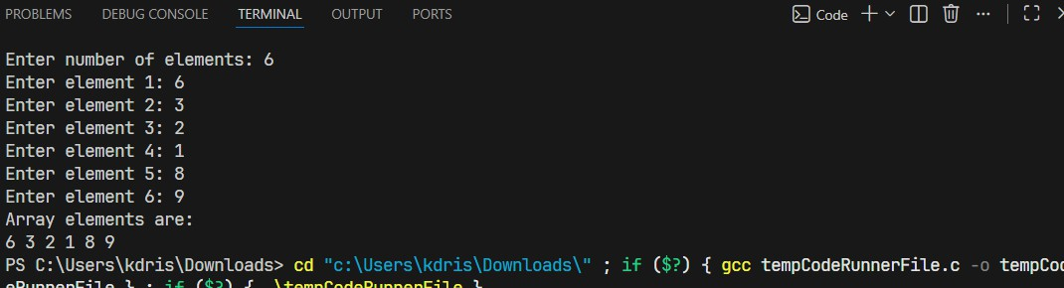
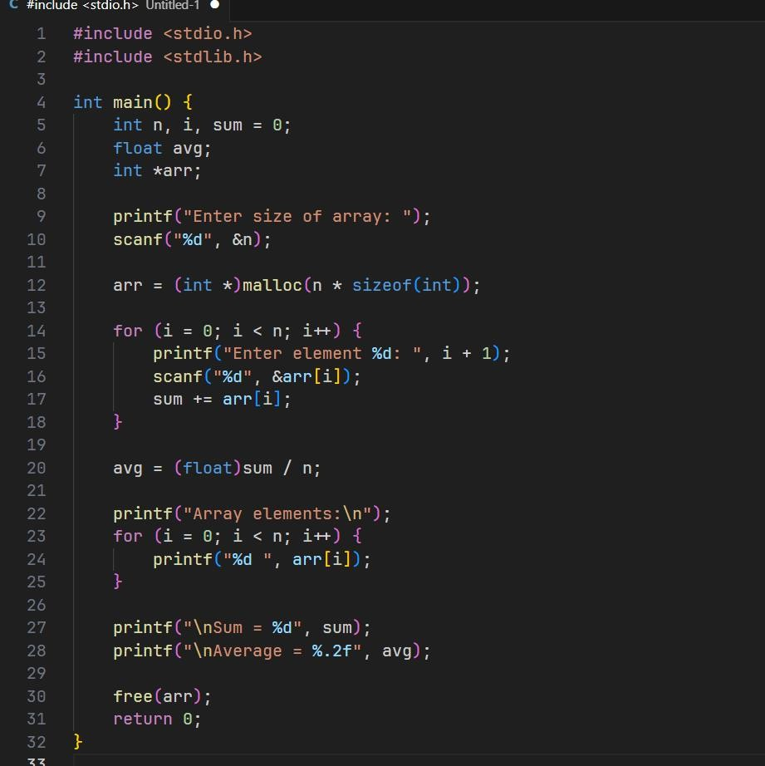
- Write a C program to dynamically allocate memory for an array of N integers and perform insertion, display, sum, and average operations.

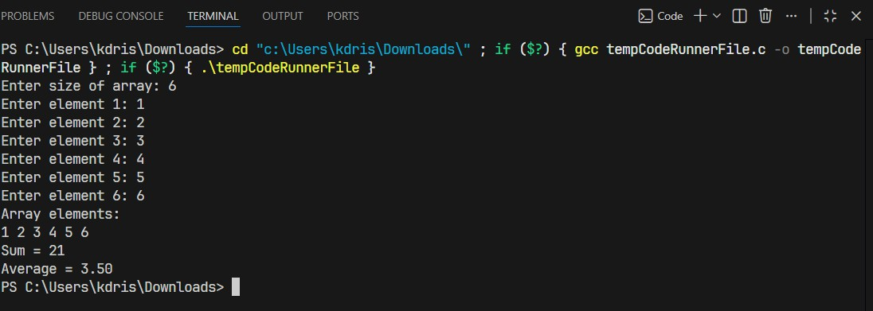
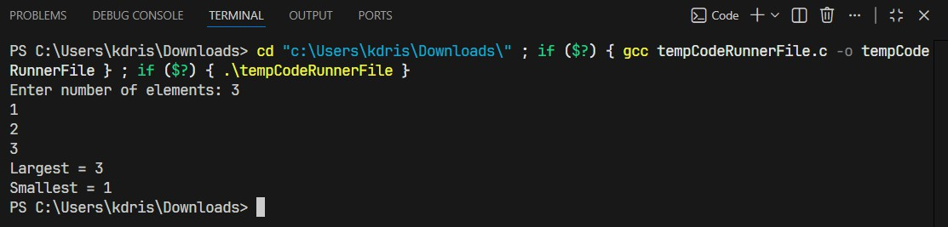
- Write a C program to dynamically allocate an array and find the largest and smallest element.

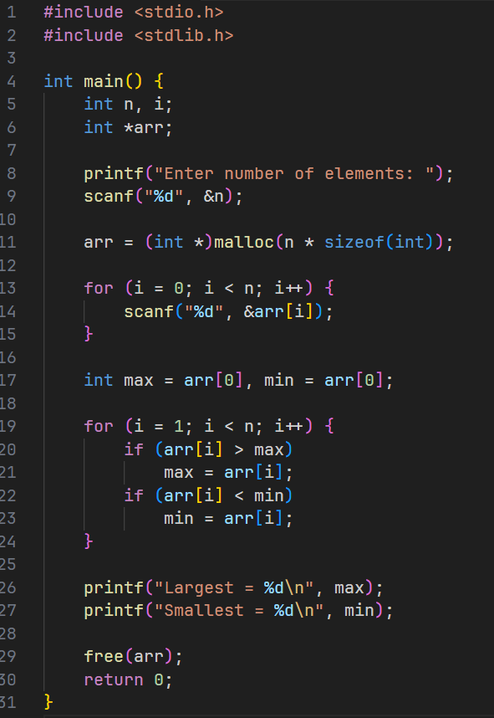

- Write a C program to dynamically allocate memory for a 2D matrix and perform matrix addition and subtraction.

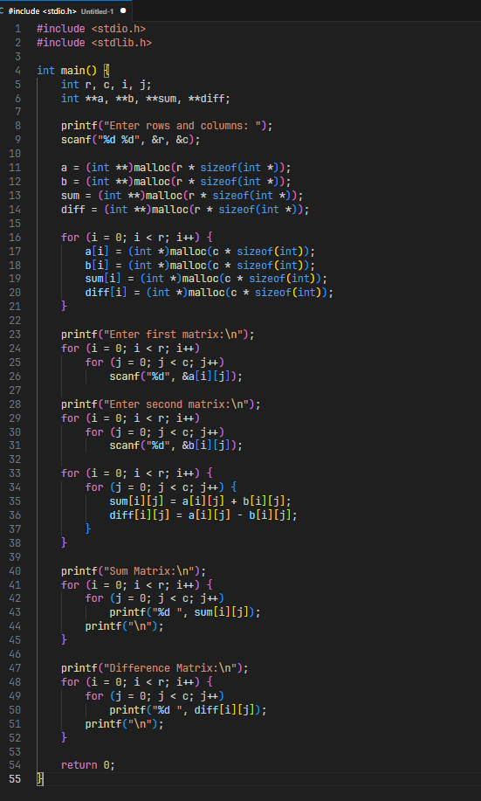

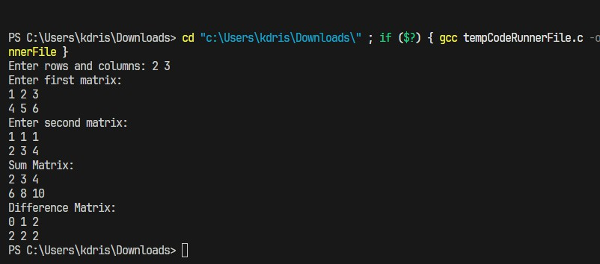
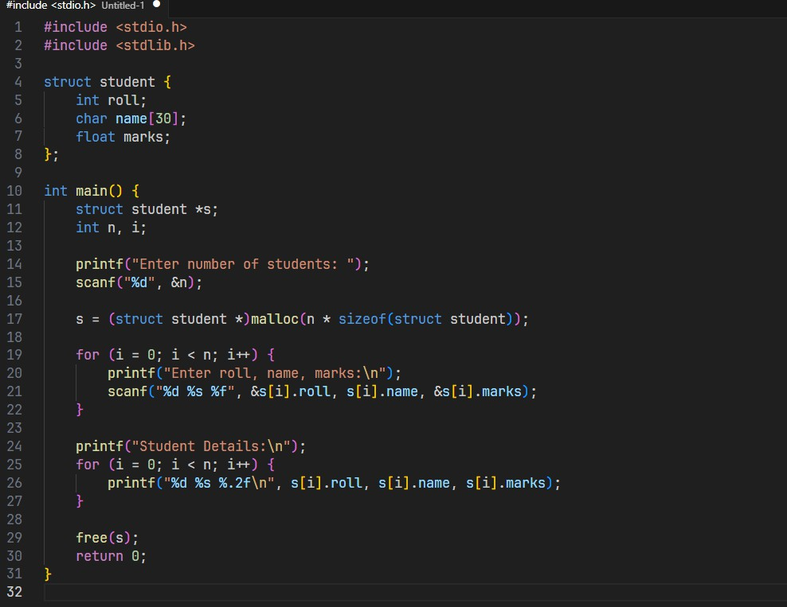
- Write a C program using structure and dynamic memory allocation to store and display student details such as roll number, name, and marks.

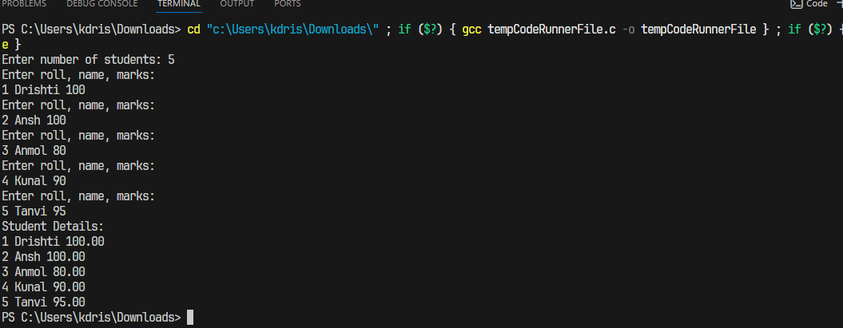
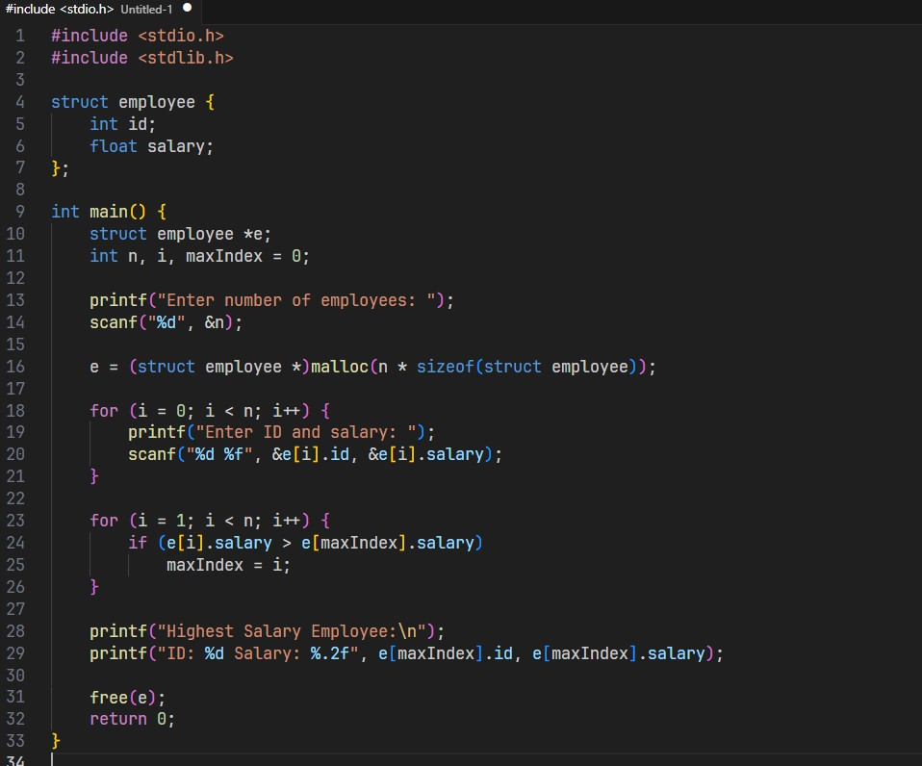
- Write a C program using array of structures with dynamic memory allocation to store employee details and find the employee with the highest salary.

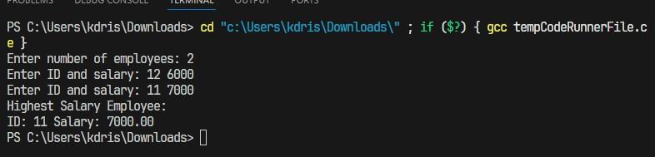

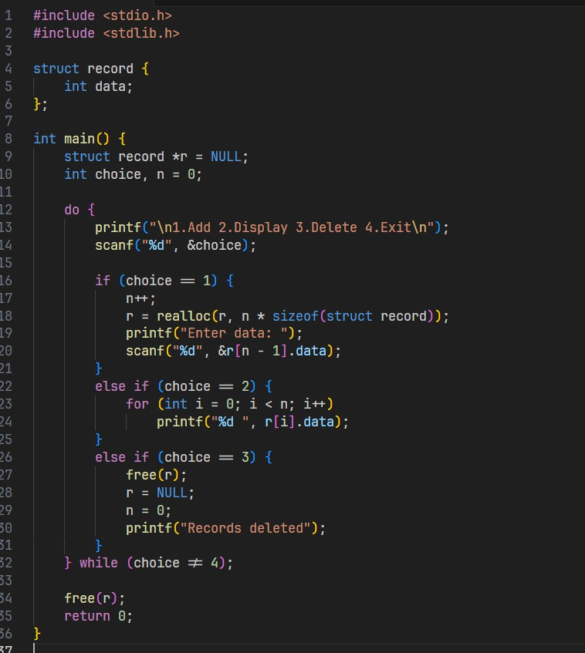
- Write a menu-driven C program using structure and dynamic memory allocation to add, display, delete records and free memory before exit.

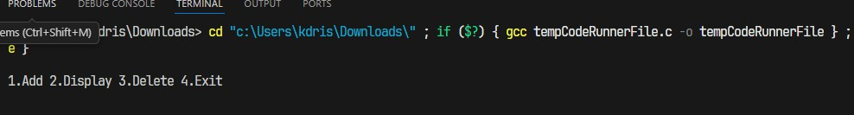
- Write a C program to demonstrate the use of union by storing integer, float, and character data and explain memory sharing.

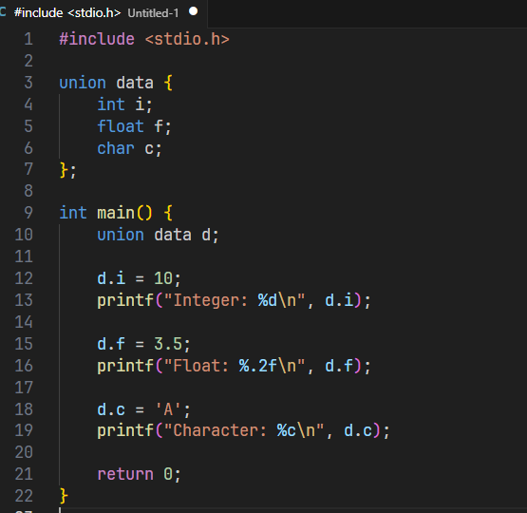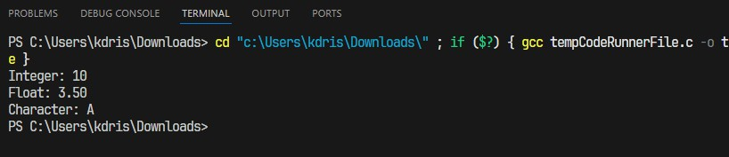
- Write a C program to show the difference in memory allocation between structure and union using sizeof().

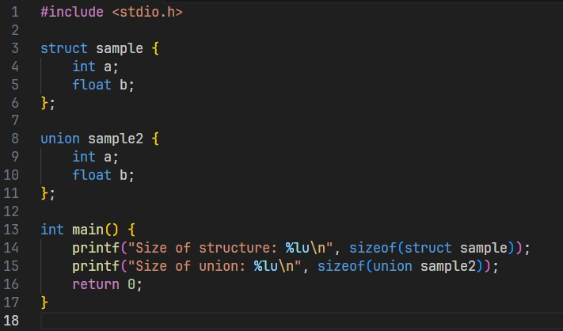

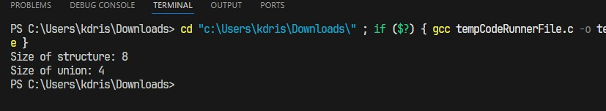
- Write a C program using structure and dynamic memory allocation to sort student record based on marks.

